Lab Session | Topic
1 | Introduction to Threads - Pthreads
2 | OpenMP – Basic programs such as Vector addition, Dot Product
3 | OpenMP – Loop work-sharing
4 | OpenMP – Sections work-sharing
5 | OpenMP – Combined parallel loop reduction and Orphaned parallel loop reduction
6 | OpemMP - Optimization (loop interchange, unrolling) and Profiling
7 | Java RMI - Sample Demo
8 | MPI – Basics of MPI
9 | MPI – Point to Point Communication between MPI process
10 | MPI – Non-Blocking Communication
11 | MPI – Synchronization between MPI process
12 | MPI – Collective Communication and Data Movement between MPI process
13 | MPI – Collective Communication between MPI process
14 | Introduction to CUDA, Array Processing using GPU
15 | Vector and Matrix Processing using GPU
16 | FAT LAB
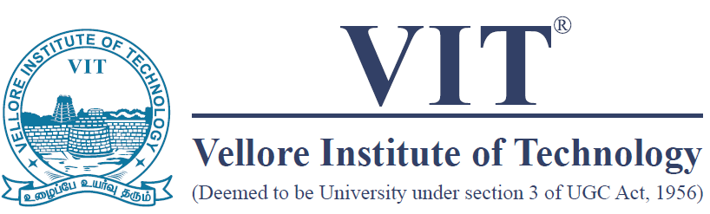

School of Computer Science and Engineering (SCOPE)
Course Code: CSE4001
Course Title: Parallel and Distributed Computing
Semester: Fall 2022-23

